

**School of Engineering**

**Product Design and Management**

**Individual Project Report**

**ENGG660**

**CONCEPTUALISATION DESIGN AND DEVELOPMENT OF A MOBILE VR SIMULATOR BASE**

**Author:**

**Swaraj Patra, 201596665**

**Contact No: 07883130769**

**Date of Submission: 27 Aug 2022**

**Academic Guide: Prof. Dan Hibbert**

# Summary

This paper includes a comprehensive report on the results and sources of inspiration that lead to the design produced for a Mobile simulator base. The findings of the market research led to the conclusion that even though the number of residential users of racing simulators is higher than the number of commercial users, only a small percentage of those residential users own a cockpit. As a result, it would be beneficial to develop a product that can easily adapt to the commercial market while still being able to attract residential users. Keeping this in mind, the device was intended to have a straightforward appearance while also being able to fit in with the surrounding gaming environment. This is accomplished by giving it a sturdy but simple design and lighting that is as understated as possible. The control panel is located on the front face of the base, while the foot lever is located on the rear of the base. When you step on the foot lever, the back half of the base glides downward, hiding the wheels while also locking them in place. There is a plate located above the foot lever that is supposed to look like a licence plate. This plate may be pushed to release the brakes, which allows the lower half of the base to be lifted back up, giving the base its mobility. For customers who want a higher base, the overall height of the base is 16.5 centimetres. To make the frame taller, more segments measuring 10 centimetres may be placed in between the already existing ones without the need of any power equipment. The base is also constructed to be far stronger than what is necessary in order to accommodate the potential addition of a motion simulator to the base. Its compatibility with cockpits of varying lengths is made possible by the fact that it utilises two pieces to support a single base.

In addition, the study delves further into the modelling of the parts, the selection of the materials, and the functioning of each element, providing a complete explanation of each item and the thinking process involved with it.

# 2.0 Table of Contents

1.0 Summary 2

2.0 Table of Contents 3

3.0 List of Figures 5

4.0 Introduction 5

5.0 Concept Development 8

6.0 Detailed Design 12

Base Frame 13

Main Frame cover 14

Support structure 15

Support connectors 17

Top cover 18

Metal mounting board 19

Under Mount board 20

Top connecting Bolt 21

Light diffuser casing 22

LED housing 23

Tension panels 24

Control Panel 25

Wheel 26

Breaking gear 29

Base Cover 30

Breaking pad support 31

Brake pads 32

Foot lever 33

Base Gripper 34

Cam Lever 35

Cam plastic bearing 36

Cam slider 37

Cam Handel 38

Hinge joints 39

Hinge joint plastic bearing 40

Bolts and nuts – 41

7.0 Conclusions 42

8.0 References 44

9.0 Bibliography 44

10.0 Appendix 45

10.1 ETHICS AND SUSTAINABILITY STATEMENT 45

10.2 Product Design Specification (PDS) 47

1. Summary 47

2. Contents 49

3. List of Figures 50

4. Introduction 51

5. Product Design Specification 52

5.1 General Product Description 52

5.2 Commercial Considerations 52

5.2.1 The Customer 52

5.2.2 The Market 53

5.2.3 Competitor Information 56

5.2.4 Estimated Market Revenue 59

5.2.5Marketing Strategy. 60

5.2.6 Unique Selling Points 61

5.3 Performance Specification 63

5.3.1 Functionality 64

5.3.2 Materials 69

5.3.3 Dependability 72

5.3.4 Environment 75

5.3.5Ergonomics and aesthetics 78

5.3.6 Interface 81

5.3.7 Cost and Timing 84

5.3.8 Training and Safety 86

5.4 Regulatory Requirements 89

5.4.1 Legislation 89

5.4.2 The following patents should not be breached- 90

6. References 94

7. Appendix 95

10.3 Manufacturing Data: 97

10.4 Analysis- 128

10.5 Miscellaneous: 134

# 3.0 List of Figures

Figure 1-6

Figure 2-7

Figure 3-9

Figure 4-11

Figure 5-13

Figure 6-14

Figure 7-15

Figure 8-16

Figure 9-17

Figure 10-17

Figure 11-18

Figure 12-19

Figure 13-20

Figure 14-21

Figure 15-22

Figure 16-23

Figure 17-24

Figure 18-25

Figure 19-26

Figure 20-27

Figure 21-28

Figure 22-29

Figure 23-30

Figure 24-31

Figure 25-32

Figure 26-33

Figure 27-34

Figure 28-35

Figure 29-36

Figure 30-37

Figure 31-38

Figure 32-39

Figure 33-39

# 4.0 Introduction

Since they were originally released in 1972, driving games have been very successful, and they now have the greatest market share in the gaming business. Racing simulators are the most recent development in this sector of the gaming industry. A realistic driving experience may be generated by using realistic automotive controls, surround screens or virtual reality (VR), and seating arrangements, which are occasionally combined with motion simulators. In spite of the fact that its primary use is gaming, it is also utilised for the purpose of testing and teaching drivers.

The creation of a moveable platform for the Simulator Cockpit is the primary objective of this project. The term "cockpit" refers to the enclosed space of a racing automobile that is designed to simulate the driver's seat. Despite the fact that a cockpit does not provide a significant contribution to the amount of data received from the game, it is an essential component for motion simulation. For the purpose of this endeavour, the base is designed to be compatible with a Formula PLAYSEAT, which is a well-known cockpit manufactured by the PLAYSEAT firm and designed to simulate the driving position of an F1 racing vehicle.

Figure 1 Formula PLAYSEAT

Figure 2 Formula PLAYSEAT

Figure 3 Formula PLAYSEAT

Figure 4 Formula PLAYSEAT

The market for such a device is now somewhat limited since users need to own a cockpit in order to find the base helpful, and cockpits are expensive enough that not everyone can buy one. Nevertheless, during the COVID-19 shutdown, corporations like NASCAR organised simulation racing events with professional drivers. This contributed to a rise in interest in the sport of sim racing. Since the release of Covid, there has been a rise in the number of arcades and other commercial centres that provide sim racing. This demonstrates that there is an opportunity for a market in the business area, since simulator rigs now account for 41% of the overall market share.

Figure 2 Global simulator market

When it comes to owners of residential cockpits, the competition now comprises of improvised or do-it-yourself configurations. The employment of customised flight cases has been seen in a significant number of commercially owned Sim units as well as privately owned Sim units, however some commercial centres make use of custom-built frames. Taking into consideration the two different types of units, a few things can be observed. These things include the fact that even though they have additional space, the majority of it is unused; people like having brandings and logos around their unit; the majority of them do not have any mobile function; and very few of them can support a motion simulator. Taking all of these factors into account, a concept for the mobile base is devised.

The first stage of the project has a focus on gaining a deeper comprehension of the product, its applications, and the market, all of which were covered in the previous stage. Moving ahead with the use of this knowledge together with some basic design insights, a PDS is developed along with safety requirements to provide a guideline for the process of conceptualization. where a single idea is chosen from among all of them by a method called concept variant analysis. The idea that has been completed is based on aspects such as modularity, the ability to accept motion simulators, flexibility in size and height, prospective commercial applications, and so on.

The project will then go on to the detailed design phase when this stage is completed. During this phase, all of the ideas for the subcomponents will be established with regard to the materials, manufacturing method, and assembly that will be used. They are then modelled further on CREO with the most exact measurements possible so that it may become a reference for the engineering and manufacturing team so that they can further modify it to get it suitable for manufacture.

# 5.0 Concept Development

The Product is a form of accessory that can readily support not just PLAYSEAT but also the majority of cockpits, and it is designed specifically for users of contemporary PLAYSEAT. Because the cockpit in a PLAYSEAT is not very wide and has a body made entirely of metal, which leads to a number of significant problems, the product is necessary for users of PLAYSEAT. Problems When the driver makes an imbalanced movement, the narrow body has a greater chance of falling over. If the metallic body is allowed to remain directly on the floor, this might potentially cause damage to the cockpit as well as the floor beneath. The majority of PLAYSEAT platforms are durable, although it might be challenging to move them around. There is not a single modular component on the PLAYSEAT foundation, which results in an extremely limited number of functionalities. In order to solve this problem, you need design a base that has a larger surface area than the frame and is capable of preventing it from falling over. The frame will be made more robust by the use of the base, which will also have the ability to move. It is necessary to include slots and mounts in order to make the base modular so that it may deliver more than just the most fundamental functions.

At this point, the research that is required to correctly identify and define the product that will be developed is carried out. It entails a number of processes, each of which provides us with a greater grasp of the requirements of our customers and what would be financially feasible.

Major motivating factors behind the creation of a moving platform designed particularly for virtual reality simulators are motivating factors. The development of new technologies The advancement of virtual reality technology has made the experience both more accessible financially and qualitatively. It is anticipated that there will be a rise in demand for gear that can support this experience as their popularity grows. Market gap There are currently no commercially available Bases designed to support virtual reality simulators. Opportunity PLAYSEAT is a key participant in the field of virtual reality cockpits designed for use in virtual racing, and as a result, the company has a bigger client base.

There is a deficiency in the market regarding the availability of certain platforms for PLAYSEAT. The PLAYSEAT branded bespoke flight case is the product that sees the greatest usage on the commercial side of things. Stands made of plastic or wood are two other available choices. However, the vast majority of them are immobile.

The cost of homemade alternatives is far lower than that of a specialist product. Because of the way they typically utilise the product, residential consumers may not have a need for mobility. If the price is too low, it may not attract PLAYSEAT customers who are already using the product, and if the price is too high, prospective PLAYSEAT consumers might not purchase it.

Figure 3 Functional Analysis

The development of ideas that are able to fulfil requirements for the design of the mobile base continues. These criteria include portability, sturdiness, height that is ideal for monitor usage, mounting with the majority of VR simulators, but high compatibility with the PLAYSEAT. It is limited down to a single idea utilising Concept variable analysis, where all of the concepts that were generated in the conceptualization phase used functional solutions. This concept was chosen from among the 10 concepts that were developed. The ideas are to be evaluated according to the criteria that have been established, and then ranked in order to find the top three, from which the most feasible idea will be chosen to proceed into the detailed and embodiment design phase. The criteria that will be used are as follows: stability, height adjustment, reliable mobility, reliable locking, easy manufacturing, easy assembly, modularity, and brand visibility.

Functional Solutions:

• Mounting- Screws, Magnetic mount, Clamping with mounts, Special joints.

• Height – Fixed height, Rack and pinion, Screw lift, Stacking, Crossbar mechanism

• Wheel locking- Gear locking, Caster locking, Off centre locking

• Mobility type- small wheels, Hub less wheels, Belt tracks, Rubber ball.

• Configuration-One large base, Two Bases for each end, Four bases for each corner.

• Materials- HDPE, Aluminium, Stainless steel, Rubber, PP (transparent)

• Eco friendly options- Recycled aluminium, recycled HDPE, Recycles shoe soles for griping, wood for main body.

• Modules- Keyboard holder, VR headset Holder, Motion simulator, Game lighting, Side table.

Figure 4 Render of final concept

The design which will is moved forward to the detail design phase takes its cues from the straightforward yet rugged aesthetic of a variety of electronic modules, such as the TWS earphone case and custom-built CPU. It will also feature subtle lighting to help it blend in with the atmosphere of a gaming environment. Because this would make it suitable with cockpits of varying lengths, it does not have a single, continuous base; rather, it is separated into two parts of equal size. Despite the fact that the width is another constraint that may differ from cockpit to cockpit, it is possible to find a solution in the form of customised clamping. It was chosen that the width should be somewhere around 71 centimetres, which was based on the average width of doors. The ability to vary the height of the display is necessary for its operation and may also be desirable for aesthetic reasons. Both of these approaches were taken into account in order to accomplish height flexibility. The first used a stacking frame with fixed dimensions, while the second made use of a lead screw. The use of a lead screw would provide a vast range of adjustment; however, it would be time consuming to set up and there is a possibility that it may generate an imbalance between the front and rear unit, which would tilt the cockpit. For these reasons, the design of stackable components was chosen. A square section steel frame is used to keep the integrity intact because it has fewer sharp edges, which prevents damage to the components that are surrounding it. The dimensions of the frame are chosen so that it can support the static weight as well as the dynamic load that is caused by motion simulators. The load from the mount is carried from the top mount to the steel frame through plastic support structures that are capable of absorbing impact without deforming. The wheels that are built into the frame are responsible for transferring this weight to the ground. in order to gain mobility There are four industrial wheels employed, and a rubber gripping system is added to accomplish locking. When the platform is locked down, this will not only provide locking of the brakes, but it will also lower the ground clearance, providing the base more surface area and preventing it from toppling over. In order to accomplish modularity, the top cover has a number of different mounting points, and there is also the opportunity to add individualised components to the support portion. The outside surface is spotless and devoid of any connection points; as a result, it lends itself well to the effective use of available space when bringing in logos and patterns.

# 6.0 Detailed Design

Even though the product may be put together in a modular way, the initial product still consists of the essential components and sub-assemblies that are required for its production. This is the case even if the product can be formed in a modular fashion. When picking components and functionalities for the set, careful consideration is given to how they would enhance the design while also keeping the user's safety in mind. This is done in order to avoid any accidents. The mechanisms for moving the base and breaking the wheel, as well as attaching the gripper to the base dimension of the main frame, are the pieces that need to be taken into account. Mountings support framework etc. The Outer dimensions of the product are – L710*W330*H165 mm.

### Base Frame

Figure5 Base frame

material- Cold formed S420.

Quantity-1

The fundamental frame may be broken down into four individual pieces. components include the outside frame, wheel holders, and the connection for the actuation mechanism

The outermost portion of the framework is made up of a square steel piece that has a wall thickness of 3 millimetres and measures 50 millimetres in length overall. This particular material was selected because it is capable of providing an elastic bending moment resistance of 3.27 kilonewton metres. This enables it to endure a static load of 200 kilogrammes in addition to the dynamic loading that is created by the motion simulator pistons. It is composed of two different components: a pair of pieces that are bent, and a pair of pieces that are straight.

The wheel holder is manufactured using U-shaped beams that have a section size of 50 millimetres and a thickness of 2 millimetres. The load is transferred from the outside frame to the connection, which transmits the load to the wheel, which transfers the load to the floor. Utilizing a screw as its primary method of holding the wheel sub assembly together is what it was designed to do.

Installing the actuator mechanism requires the use of this plate, which has dimensions of 30 millimetres by 20 millimetres and a thickness of 2 millimetres. This bar, which is used to construct the plate, is in the shape of an L, and its dimensions are 30 millimetres by 20 millimetres.

The last component is a set of M20 hex bolts made of SS316 bolts and measuring 18 millimetres in height. The support structure is connected by means of these bolts, which function as connectors.

First, during the manufacturing process, all of the components are cut to the appropriate dimensions. Next, the outer C section is hot bent into the desired shape. Finally, as the components are exceptionally compatible with one another, they can be simply welded together.

Coatings: After having the whole frame zinc powder coated, it is put into an oven to be baked in order to acquire the final rustproof finishing. This ensures that the coating adheres properly.

Main Frame cover

Figure 6 Main Frame cover

Material- recycled HDPE

Quantity-1

The cover for the main frame has many functions: it protects the main frame from scratches, which extends its lifespan; it also holds the control panel; it keeps the lighting in its proper position; and it ensures that the base of the device is properly aligned.

In terms of its functionality, it offers sufficient surface area that may be used in the display of patterns and logos. The main frame does not receive any of the stress from the simulator, thus it was constructed with a wall thickness of 3 mm to be able to bear tiny hits from the side. This ensures that the main frame can withstand any impact from the sides.

In order to install it, little flaps are produced on the inside, and these flaps sit on the main frame. The connection of the support structure then helps to tighten the flaps.

manufacturing– It is manufactured by injection moulding of HDPE, and the holes are positioned on the exterior sides of the product rather than running vertically. After that, the grooves that will hold the lighting panel are machined in, and then 8mm holes are drilled and threaded with M8 at a pitch of 1.25 to connect the control panel.

Printing Even though high-density polyethylene (HDPE) is one of the most difficult materials to print on, it is nevertheless possible for anybody with the right equipment to print on it. Printing may be done in a variety of ways, including by using vinyl wrapping, laser engraving, and the use of aliphatic polyurethane powder.

### Support structure

Figure 7 Support structure 1

Material- ABS+30% glass fibre

Quatity-6

Figure 8 Support structure 2

Material- ABS+30% glass fibre

Quatity-6

It has a tensile strength of (60MPa) and an elongation of under 2%, which implies that the support structure is much more long-lasting than the needed restrictions. The support structure is manufactured out of ABS that contains 30% glass fibre.

The support structures are there to facilitate the direct transmission of weight from the mount plate to the base frame, as well as to facilitate the connection of the many segments that are added to the main body. They feature an M20 internal threading that has a pitch of 2.5mm, which makes it easier to connect the various segments of independent support. In addition, there is a groove for interlocking the supports, ensuring that they will not move while the connecting bolts are being tightened. Additionally, the grove serves as a support structure in the event that additional segments are added to the fundamental unit in order to enhance the height.

After the outer body has been attached to the main frame, as shown in the figure to the right, the support structure 1 is attached immediately above the hex nuts. In the case of the fundamental configuration, support structure 2 is installed immediately above support1, but in the event that extra segment components are required, further support 2 parts must be added.

Manufacturing– They may be manufactured by injection moulding, with the channels being placed on the top face of the support structure.

### Support connectors

Figure 9 Support connectors 1

material - SS316

quantity -6

Figure 10 Support connectors 2

material - SS316

quantity -6

It is a threaded rod with an Allen keyhole on the top with thread size of M20, and pitch diameter of 2.5mm.

These connectors help in fastening the support structure to improve the connection by making them sturdier. The Connector one is used to connect support1 to main frame and connector 2 is used to connect support 2 to support 1 and all succussive connections.

Manufacturing- They are outsourced from McMaster-Carr.

### Top cover

Figure11 Top cover

Material- Recycled HDPE

Quantity-1

The top cover has a thickness of 4 millimetres, and its construction takes into consideration the possibility that it may be subjected to a light stress from the front faces of the mounts that are positioned on top. This component is there so that it may fulfil its function of covering the top region that is located between the mount and the support structures. It features a groove on the top side that is intended to be used for mounting, and the inner section of that groove is intended to rest on top of the support structure in a position that is aligned with the heads.

manufacturing– It is manufactured by injection moulding of HDPE, and the holes are positioned on the exterior sides of the product rather than running vertically.

Printing on HDPE may be difficult since it is one of the most difficult materials to print on, making it difficult for anybody who does not have the appropriate equipment to print on it. Printing may be accomplished by a variety of methods such as laser engraving, the application of aliphatic polyurethane powder, the addition of vinyl wrapping, etc.

### Metal mounting board

Figure 12 Metal mounting board

Material-SS316

Quantity-1

It is a metal board made of steel that is 2 millimetres thick and has 72 holes that are spaced 40 millimetres apart from one another. These holes are designed to accommodate m12 bolts, which are a typical size used to connect bolts in heavy duty mountings.

The stainless steel plate is there to provide a metallic look on the top, and it is held in place by an Acetal Copolymer + 30% Glass Fiber of the same size underneath so that the weight may be distributed evenly and the mount can remain lightweight. The two surfaces are bonded together with the assistance of an adhesive that is based on polyurethane.

In the manufacturing process, a metal sheet is first cut with a laser, then the exterior holes are reamed, and finally, the surface that will be bonded is sanded.

### Under Mount board

Figure 13 Under Mount board

Material- Acetal Copolymer + 30% Glass Fiber

quantity- 1

It has the exact dimension as the metal plate with thickness of 6mm and is placed between the support structures and top metal mount plate. It helps strengthen the integrity of the mounting platform while also distributing the load to all support structures.

Manufacturing – The shape is moulded using injection moulding with indents for holes after which holes at centre are drilled while the holes at the end are tapered. and the surface to be bonded is sanded

### Top connecting Bolt

Figure 14 Top connecting Bolt

Material- SS316

Quantity-2

Mounting boards are fastened to the moving base using these M20 bolts, which are specifically designed for that purpose. The two screws attach themselves to the support elements that are located in the four corners of the base.

After the mounting boards have been fastened to the PLAYSET with the use of bolts, the playset and the mounting boards themselves are next linked to the moving base. This method is chosen because it is straightforward to line with the groove that is already existent on the top cover and the mount plate.

Manufacturing is handled by MC Master CARR on a contract basis.

### Light diffuser casing

Figure 15 Light diffuser casing

Material- Transparent PP

Quantity-4

This is a cover that is made to cover the LED light holder in order to protect it from damage that could be caused by exposure to moisture and water. In addition, the cover serves the purpose of diffusing the light that is emanating from the led in order to illuminate the light panel in an even manner. A matte finish is applied to the inner surface so that the diffusion may take place.

In the manufacturing process, the component is created by injecting ABS into a mould, and after that, the interior region is either given a matte finish by spraying varnish on it or by sanding it with sandpaper that has a grit of 440.

### Diagram Description automatically generatedLED housing

Figure 16 LED housing

Figure 16 LED housing

Figure 16 LED housing

Figure 16 LED housing

Material- PP and LED strip

Quantity- 4

It’s a housing that consist of Plastic casing with LED strip of thickness of 4mm attached to the top. which has opaque glossy finish to reflect the light scattered inside. This housing is then adhered to the casing with matte finish on the inside to make a protective seal.

After the assembly of Lighting panel, it is slid inside the grooves present at sides of base or base cover which are then secured and unable to move after the support structure is installed.

The led panels can be powered by connecting to the control panel. In scenario where multiple panels are stacked the lights can connected to power distributer present in the panel that can make a parallel connection with the control panel.

### Tension panels

Figure 17 Tension panels 1

Figure 17 Tension panels 1

Figure 17 Tension panels 1

Figure 17 Tension panels 1

Material-pp

Quantity-2

Figure 18 Tension panels2

Figure 18 Tension panels2

Figure 18 Tension panels2

Figure 18 Tension panels2

Material-PP

Quatinty-2

The panel has a thickness of 0.7 mm and varying inner diameters so that it may be used in a variety of situations. These are snugly inserted between the base's outside surface and the space between the individual light panel units. This is known as a fit through tolerance, and it results in a product in which the panel and the main body of the product have a very close fit.

Manufacturing - The PP material is injected into a mould to create the component.

### Control Panel

Figure 19 Control Panel

Material- HDPE & PCB boards.

Quantity- 1

The Panel serves as a central point of connection and control for the lights. It features a port to link parallelly to the stacked-up units that already have inbuilt connections for LED panel existing in them, and it can connect to a total of four LED panels simultaneously. Additionally, the control board has a connection that allows additional cables that are necessary to run motion simulators to be plugged in. The LED lights are powered by the control panel, which features USB connections that are utilised to provide electricity to the panel itself.

### Wheel

Figure 50 Outer Wheel

Material -Polyurethane

Quantity- 4

Figure 21 Inner wheel

Material- Polypropylene

Quantity- 4

The wheel cores have the ability to absorb any impact that is applied to the wheel. When combined with an outer wheel, they are able to give smooth motion. The specifications were drawn from those of already existing wheel manufacturers and have been rated to have a load bearing capability of 175 kg apiece.

Bearings, which are responsible for the wheels' motion, are used to join them to a shaft, which is connected to the base frame. The base frame is then connected to the wheels. Both sets of wheels are put as widely apart as physically practicable inside the base frame once the location has been chosen to ensure that there is sufficient room for rotation in both sets of wheels.

To do this, there are two M3 threaded holes located on each sides of the wheels. This allows the wheel core to be further changed so that it can fit a PP gear on both sides of the wheel. This gear will be utilised to provide stronger gripping when the wheel is being broken. It causes them to become permanently attached to the wheel, making it such that when the gear is blocked or locked, it also locks the wheel.

Manufacturing entails outsourcing the component, which is followed by modification that entails drilling holes and threading them.

### Breaking gear

Figure 22 Breaking gear

Material- Polypropylene

Quantity- 8

These are designed to fit with the prefabricated wheels that have a connection that is made up of two screws. When in motion, the gear is intended to avoid coming into contact with the shaft or any other surface that may cause it to break by mistake.

In the first step of the manufacturing process, injection-moulded components are machined on a gear milling machine. At this stage, the parts also get two drilled holes measuring 3 and 5 millimetres in diameter, respectively.

### Base Cover

Figure 23 Base Cover

Material- Recycled HDPE

Quantity- 1

The ability to lock and unlock the product is provided by the base cover, making it one of the most crucial components of the product. Despite the fact that it is not required to constantly take in a lot of loads, it should be able to withstand scenarios in which it is dangerously close to tipping over, such as when there is an excessive amount of weight on the corners. The wall thickness is stated as about 4 millimetres to ensure that the foundation is able to withstand this. In addition to that, an impact-absorbing gripping substance is positioned at the bottom to assist minimise the force of the impact.

During the locking process, the base is moved downward by depressing the foot lever that controls the movement of the base. As the base moves downward, the ground clearance decreases, and it also pulls down the grippers that are attached to the gears that are attached to the wheels, which results in a reduction in the wheels' ability to move freely.

There are lever hinges linked along the middle of the base that may be used to lift up the base to liberate the wheel, which allows the base to be movable. The base is connected with a light panel assembly in its corners that corresponds with the main frame cover that maintains a consistent route to slide.

In the same way as the main frame cover does, they have a groove that the lighting panel is supposed to slide into, however once the pedal has been added, the panels have been stuck. In addition, the base has mounting holes for the locking brakes. They are dispersed across a broader area with three mounting points for each brake pad holder because the frame is constructed up of tiny steel plates. This is done to ensure that the force of locking is distributed properly inside the body in order to prevent the body from breaking.

Manufacturing consists of injection moulding the base, machining the grooves for the light, drilling holes for mounting the brakes, and drilling a hole to connect the hinge mechanism. The groves for the light are machined.

### Breaking pad support

Figure 24 Breaking pad support

Material- SS316

Quantity- 8

These supports include a slight protrusion at the top where the brake pad is fitted snugly owing to tolerances. The supports are made from 2mm thick stainless steel plates that are bent and hardened to form an L-shaped part that may be fitted to the base. During the process of assembling the wheel, they are to be inserted into the wheel holding slots in conjunction with the brake pads. Once the wheels have been secured in their positions, they may be removed; however, even though they have a liner motion, they are unstable since their bases are not connected at the bottom. Once the bases have been secured, however, they follow a liner route. If the brake pad ever attempts to detach itself from the wall where it is attached, the C beam that houses the wheels will prevent that from occurring.

During the manufacturing process, the steel pieces may be cut using a water jet or a laser, and then they are bent at an angle of ninety degrees.

### Brake pads

Figure25 Brake pads

Material – Rubber

Quantity- 8

These are little brake pads made of rubber, and they have teeth on them that grab the gear that is linked to the wheels. When the base is pushed downwards, they press on the gear teeth, which causes them to slow down and eventually line themselves into a lock position.

### Foot lever

Figure 25 Foot lever

Material- HDPE

Quantity-1

The form on the front is there just for aesthetic appeal, while the interior sections are designed to be able to correctly distribute force and make the down-and-out action of the base more even. The shape at the front of the base. The holes are intended to be used for mounting this lever to the base in order to strengthen the connection and ensure that it remains in its current location.

Injection moulding of recycled high-density polyethylene throughout the manufacturing process.

### Base Gripper

Figure 26 Base Gripper

Material- rubber

Quantity-1

When the mobility of the vehicle is locked, it helps to absorb shocks and have a strong hold on the ground thanks to this component, which is located underneath the base cover. It contains holes that are grooved for the bolts that hold the brake supports in place. the fasteners Also, attach a layer of fine Velcro sheeting to the underside of the base cover, while sticking the other piece of Velcro to the rubber sheet. This will enable the user to easily remove and reattach the support as needed.

### Cam Lever

Figure 26 Cam Lever

Material- A356

Quantity- 4

The design of the lever is such that it can accommodate the height variation in the slider as well as the placement of the joint. While the other hole is designed to connect with the flapping handle that is used to activate the lever, the hole in the form of an oval serves as a cam that allows the hinge to continue its route.

Manufacturing – Milling and drilling.

### Cam plastic bearing

Figure 28 Cam plastic bearing

Material- Acetal

Quantity- 4

When it comes to the interplay between different types of plastic, the material is very smooth and functions admirably as a Bering. The component is used to decrease friction and wear caused by usage, and it is tension fit into the aluminium lever. It also interacts with other plastic bearings in the mechanism.

Manufacturing- Injection moulding of Acetal.

### Cam slider

Figure 29 cam slider

Material- HDPE

Quantity-1

Because of its polished surface and many minute grooves, it functions as a cam lever slide. The cam handle is then put on top of a base frame, and the cam lever is fastened to it once it has passed through and secured on the other side with the cam handle. The form of the cam lever is such that it compensates for the difference in height between the slider and the pivot point of the hinge.

### Cam Handel

Figure 30 Cam Handel

Material- ABS

Quantity- 1

It is a handle that is attached to the cam lever, and by pulling the flap, it may assist in activating the cam lever. To raise the base up and recover mobility, the flap may be pulled to move the hinge mechanism. This can be done by moving the base down and locking it down as it is pushed down. The purpose of the hole in the form of an oval is to improve grip on the flap.

### Hinge joints

Figure 31 Hinge joint 1

Material- ABS+30% glass fibre

Quantity-2

Figure 61 Hinge joint 2

Material- ABS+30% glass fibre

Quantity-2

The high strength of the material was a deciding factor in its selection since it was anticipated that the process of actuating the hinge would entail a significant amount of axial force.

After the longer end of hinge 1 has been connected to hinge 2 by a similar setup with the use of a bolt with plastic bearing, the wider end of hinge 1 is connected to the base frame by a bolt that has a plastic cover to act as a bearing. This is followed by the connection of the shorter end of hinge 1 to hinge 3 by a bolt with plastic bearing. After the narrower end of hinge 2 has been secured between the two cam cavities on the plastic bearing, the wider end of hinge 2 is next linked to the base cover using an n-bolt that also has a plastic bearing. This completes the assembly.

This assembly creates a mechanism that becomes straight linking mechanism that is hard to fold given the linier motion of the base cover hence the flap is to be used that actuates the Cam to fold the hinges. in this mechanism Springs could be used maintain a tenson between the joints to make a bistable mechanism but had to select tight tolerances to obtain stiffness in the mechanism due to uncertainty of reaction from a spring.

### Hinge joint plastic bearing

Figure 32 Hinge joint plastic bearing1

Material- acetal

Quantity- 2

Figure 33 Hinge joint plastic bearing 2

Material- acetal

Quantity- 4

It is more economical and saves a lot of material to utilise plastic bearings instead of conventional ones. The acetal covers are used for the sections that will be interacting with each other when they are both made of plastic. While the remainder of the plastic bearings were utilised in the rest of the connection points, plastic bearing number 1 was used to link the hinge to the base frame.

### Bolts and nuts –

Material- S316

Hinge joint 1 = 2 Allen key Bolt- M10*55mm, 2 Hex Nut M10*5 mm

Hinge joint 2= 2 Allen key Bolt- M10*45mm, 2 Hex Nut M10*5 mm

Hinge joint 3= 2 Allen key Bolt- M8*65mm, 2 Hex Nut M8*5 mm

Foot lever joint= 6 Allen key Bolt- M8*12mm

Brake support = 24 Allen key Bolt-M6*8mm, 24 Hex Nut- M6*4mm

Flap Joint = 2 Allen key Bolt- M8*35mm, 2 Hex Nut M8*5 mm

# 7.0 Conclusions

The objective of the project was to design and develop a mobile simulator base that is suitable for use with the formula PLAYSEAT. Because the industry is relatively undeveloped but expanding, a product that is targeted especially at clients in the commercial and professional arena has been developed. The capabilities of the finished product are straightforward, and they consist of being able to attach a base to the chassis in order to strengthen the product's stability and allow mobility when it's necessary to do so. Although these functions may be acquired without much difficulty, the complexity of the project will rise if the method by which these functions are achieved is refined.

When it comes to the design of the mobile base that is presently being created, the emphasis is on making it simple for the user to run the mobile base after it has been installed, while also providing the chance to update. With a frame that is far stronger than the minimum limit, a stackable assembly style, and top mount plates, this product offers its user the ability to alter and enhance basic units in accordance with the needs of their specific application. The aforementioned enhancements may range from relatively minor tweaks like more mounts, illumination, and storage space to more substantial additions like the incorporation of motion simulators, stacks, and racing simulator consoles with built-in CPUs. The modularity of the product is not very well developed, but it does have the ability to easily include new features or adjustments. In addition to the modular design, efforts are being made to simplify the operation of the basic unit by implementing a locking and unlocking mechanism that only requires a single motion, as well as a mounting process that only requires a few steps. This will help increase the range of cockpits that are compatible with the design by allowing for the creation of suitable connectors.

Using the current model and the PDS as a point of reference, the currently existing design may be modified to have a lower component count, a lighter weight, and a simpler assembly procedure. The execution of processes such as topology optimization and the usage of compliant mechanisms could be able to assist us in accomplishing this goal. Because this is a new industry with relatively few products that are designed exclusively for VR simulator cockpits, the input from customers might be beneficial in further refining the PDS and gaining a better idea of what features are desired and what functions should be omitted.

There is a lot of room for optimising the BOM in relation to manufacturing. This is because a lot of the parts could be made much thinner and lighter, or they could be substituted with much more environmentally friendly options. Despite the fact that all of the current parts are simple to manufacture and source, there is a lot of room for optimising the BOM.

# 8.0 References

* <https://civils.ai/1/free-beam-calculator>
* <https://eurocodeapplied.com/design/en1993/shs-design-properties>
* <https://calcresource.com/statics-buckling-load.html>
* <https://www.matweb.com/reference/tensilestrength.aspx>
* <https://motionsystems.eu/product/qubicsystem/qs-220-pl/>
* <https://www.playseatstore.co.uk/playseat-pro-f1-mercedes-amg-petronas-formula-one-team.html>
* <https://www.grandviewresearch.com/industry-analysis/gaming-simulator-market>
* <https://www.boltdepot.com/fastener-information/shoulder-bolts/metric-shoulder-bolt-dimensions.aspx>
* <https://www.mcmaster.com/>

# 9.0 Bibliography

* https://www.curbellplastics.com/Research-Solutions/Applications/Impact-Resistant#:~:text=Tough%20and%20durable%20plastic%20materials&text=Certain%20plastics%20such%20as%20ABS,and%20UHMW%20have%20outstanding%20toughness.
* https://tracomfg.com/material/acetal/#:~:text=Acetal%20is%20100%25%20recyclable.,more%20information%20on%20the%20process.
* https://solutions.covestro.com/en/highlights/articles/stories/2021/covestro-your-partner-2d-printed-coatings-adhesives?gclid=CjwKCAjw3qGYBhBSEiwAcnTRLreInP8qAdmIZxA1Kx1q4GtYkqSYiv1L90H-OT4eVSIOxsvJI5GNFBoC4roQAvD_BwE
* <https://www.kmsbearings.com/materials/plastic-bearing-materials.html#:~:text=Celcon%C2%AE%20Acetal%20Plastic%20Radial%20Ball%20Bearings&text=Celcon%C2%AE%20Acetal%20POM%20(Polyoxymethylene,between%20metals%20and%20ordinary%20plastics>.
* <https://www.instructables.com/Driving-Simulator-seat/>

# 10.0 Appendix

### 10.1 ETHICS AND SUSTAINABILITY STATEMENT

SCHOOL OF ENGINEERING

ENGG660: MSc (Eng) INDIVIDUAL PROJECT 2021-22

**ETHICS AND SUSTAINABILITY STATEMENT**

Ethics

*The creation of this product places a high priority on the health and safety of its final users, in addition to ensuring the observance of all relevant legal requirements and a sense of responsibility in its approach to the design process, all with the goal of producing an original product.*

Some of the things that count to provide safety and take their wellbeing into account are: high safety factor; ability to assemble without the need for power tools; absence of sharp edges; absence of offensive content; the provision of good customer service; Providing multiple functionality to its users; and the fulfilment of all performance specifications. In addition to considering the aforementioned considerations during product development, it is essential to adhere to all applicable safety and environmental laws and regulations, as well as to avoid infringing on any existing patents or intellectual Property rights. During the development phase, it is crucial to exercise caution by picking the right materials and proportions for the product.

The concept that the simulator platform can offer varied capabilities, in addition to its mobile nature, which already makes it stand out from the competition, could serve as a good unique selling point for the product.

The dangers linked with ethics are rooted in the functioning of the product, which consists of an exterior shell with a surface that may be used to show logos and patterns for commercial uses. However, marketing a product with unsuitable information might cause consumers to doubt the company's ethical standards.

To be in compliance with the ever-evolving environmental regulations, we need to give serious consideration to the worsening environmental situation and experiment with new environmentally friendly solutions.

Sustainability

*When developing the product, the effect it has on the environment is taken into account. The cradle-to-cradle methodology considers all potential outcomes before settling on one with the smallest environmental footprint.*

When working toward the goal of sustainable design, it is important to use materials that have a minimal effect on the surrounding environment without sacrificing the product's overall quality. Utilization of recycled materials whenever it is appropriate, adapting a product to be used over an extended period of time, identifying substance by marking, Simple to disassemble and requiring a less amount of composite material that is bonded together.

In spite of the fact that there is a danger involved, one strategy for reducing the weight of a product is to employ a significant number of plastic components. The vast majority of plastic components can be recycled, which makes them friendlier to the environment.

Experimenting with different environmentally friendly solutions like wood, bioplastics, cork, and so on is essential for the progression of future growth. Utilizing compliant mechanisms and regenerative design are two ways that may help increase the sustainability of a product even further by cutting down on the total number of parts and the amount of material that is used. Because this is a new ground in the market, the input from customers might be very helpful in further streamlining the product's design and making it more environmentally friendly.

### 10.2 Product Design Specification (PDS)

# Summary

*The PDS (product design specification) for a Mobile Simulator Base can be found in this document. It is broken down into three distinct sections, the first of which is market research. This section identifies the potential size of the market for a mobile simulator base by analysing the most recent developments in the driving simulation industry and arrives at a potential market range of 0.7–1.2 million pounds. Additional study on consumer needs and existing competitors assists in identifying crucial elements such as style, commerciality, height adjustability, and modularity that are necessary to attract a wide range of customers. This assists in reducing the size of the target market, which is comprised of commercial gaming hubs and arcades since these establishments are more likely to value the portable feature  of the simulator base.*

*According to the findings of the market research and an awareness of the product and the context in which it operates second section which is Performance specification are defined consisting of various factor with variable rating based on the importance of feature in regards to the product. During the phases of product development, this serves as a guideline that is followed quite closely and is not altered excessively. The PS provides a comprehensive analysis of several aspects, including their functioning, materials, reliability, environment, ergonomics, interface, training, and safety.*

*In addition to the rules that were developed to characterise performance, there is also a need to adhere to laws that are pertinent to a moving platform. the third section focuses on all of the safety constraints that need to be taken into account when the product is being developed so that it may be ready for the market. After that, a list of patents is compiled based on the probable methods that may be employed in the product in order to further prevent any potential legal concerns that could come with the product.*

# 2. Contents

Table of Contents

1. Summary 47

2. Contents 49

3. List of Figures 50

4. Introduction 51

5. Product Design Specification 52

5.1 General Product Description 52

5.2 Commercial Considerations 52

5.2.1 The Customer 52

5.2.2 The Market 53

5.2.3 Competitor Information 56

5.2.4 Estimated Market Revenue 59

5.2.5Marketing Strategy. 60

5.2.6 Unique Selling Points 61

5.3 Performance Specification 63

5.3.1 Functionality 64

5.3.2 Materials 69

5.3.3 Dependability 72

5.3.4 Environment 75

5.3.5Ergonomics and aesthetics 78

5.3.6 Interface 81

5.3.7 Cost and Timing 84

5.3.8 Training and Safety 86

5.4 Regulatory Requirements 89

5.4.1 Legislation 89

5.4.2 The following patents should not be breached- 90

6. References 94

7. Appendix 95

# 3. List of Figures

Figure 1 Formula PLAYSEAT 6

Figure 1 Formula PLAYSEAT 6

Figure 1 Formula PLAYSEAT 6

Figure 1 Formula PLAYSEAT 6

Figure 20 Outer Wheel 27

Figure 31 Hinge joint 2 40

# 4. Introduction

The famous Formula PLAYSEAT will serve as the inspiration for this project, which comprises the planning and construction of a movable base for a driving simulation. The Formula PLAYSEAT is differentiated from other driving simulator rigs by its one-of-a-kind driving posture, which imitates the stance of the driver in a formula vehicle. This allows the user to experience driving at the highest level possible. Fans of virtual Formula racing and racing professionals who want to perfect their skills in preparation for real-world competition place a high value on this kind of technology.

It would be difficult to practise racing on a variety of courses and in a variety of weather conditions in the real world, but this is made possible by virtual racing, which not only enhances the gaming experience but also allows professionally qualified drivers to practise racing on a regular basis. A stable and well-balanced base that can adjust to the user's demands is necessary for attaining a real-world-like experience in addition to the Rig, virtual head seat, steering, pedals, and so on. However, the majority of bases are not constructed to be portable, and as a result, they cannot be used to transport the system in a convenient manner.

Users of a mobile base are given the ability to transport individualised equipment in a manner with which they are most at ease. Design standards are produced in order to achieve these and other feasible enhancements in order to increase the quality of the virtual experience. These standards include a list of components that the final design should incorporate. This leads to the generation of several ideas, which, as a consequence of their interactions, provide a wide variety of concept combinations, one of which is selected to proceed to the development stage. After that, designs are crafted to address how each component is incorporated into the whole to form the finished product. After that, the comprehensive designing is done using a CAD programme to make it easier for engineers and manufacturers to produce a prototype and identify any additional modifications that need to be made before moving on to the production stage.

The stability of the rig during operation is crucial to the success of this project, and one of the potential dangers is from the question of whether or not the mechanism that will be used is reliable enough to ensure this. The components that were constructed out of the materials are strong enough to withstand the weight of the user. Because mobility increases the likelihood of an accident, the design must to be robust enough to survive moderate impacts and drops without suffering significant damage. When in use, the configuration does not place any restrictions on the user and provides them with a convenient experience overall.

# 5. Product Design Specification

Successfully completing a product requires a logical and comprehensive approach, with meticulous attention to detail throughout the design process.

The PDS is the most important instrument for controlling the project and increasing its likelihood of success. The customer's input is reflected in this control document, which details the end result that should be achieved. When completed, this report acts as a wraparound for the other stages of the design's foundation. The PDS regulates the whole design process by setting the parameters within which future designs must operate.

Therefore, the PDS has to have no ambiguity. At the conclusion of the design process, the product must be in harmony with the PDS. Weak PDS leads to a weak design, which bombs on the market. Even while a solid PDS can't guarantee a well-thought-out design, it may make it far more likely. As a comprehensive collection of criteria, the design is reframed by PDS.

## 5.1 General Product Description

It's a portable stand for virtual reality simulators, and it's designed to accommodate devices like the Formula PLAYSEAT, which simulates the experience of driving. The base can hold any regular simulator frame and roll around on its wheels for convenience. The base may also be used to attach other accessories, such as a hydraulic motion simulator, and to change the simulator's height.

## 5.2 Commercial Considerations

### 5.2.1 The Customer

Customers include VR simulator owners, arcades, Formula race training facilities, and VR racing events, since the product was developed with Formula Playset users in mind. The bulk of driving simulator setups don't have a solid base or the ability to adjust to the user's height and comfort level. When in use, the rig is more likely to topple over due to the absence of a secure study base.

The bottom surface area is increased while still enabling movement, strengthening the frame's stability. Its portability is only one of its many selling factors; other features include height adjustability, the ability to install more modules, and robust edges to protect the module while in transit.

User care and maintenance go a great way in determining the product's durability. As long as it is utilised properly and regularly maintained, it poses no risk to users. Considering the wide price spread amongst simulator rigs (often between £400 and £2000), the goal is to keep the device's pricing at or below $100.

The stakeholders include the advisory board, investors, the product development team (designers, engineers, and product managers), the manufacturing team, the marketing team, the sales department, the regulations department, the legal team, the testers, the customers, the businesses that sell virtual reality equipment, and the commercial users.

### 5.2.2 The Market

The total value of the game simulator industry was $4.04 billion in 2020, and experts predict it will grow to $9.99 billion by 2027. Based on 2016 statistics revealing the market share of each simulator game genre and their growth potential, we may infer that the driving sim will account for about 70% of the simulator market.

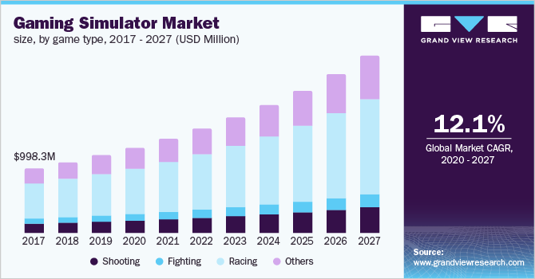

Fig1- global simulator market



Fig2- market division by game type

With a current market revenue of USD 3.9 billion, North America accounts for 35% of the market share, and firms like Hammacher Schlemmer & Company, Inc., Play seat B.V., Sony Interactive Entertainment Inc., Aeon Sim, Vesaro, and RSEAT Ltd. are among the industry's most prominent participants.

The majority of the $3.9 billion in sales are the actual parts and pieces used in a sim racing setup. A lot of variation in component prices may be expected across different user types.

There are three anticipated levels of users: novice, intermediate, and expert. How much money is needed to improve competence varies greatly.

The average cost is determined by adding up the prices of all the parts that may be utilised by the various groups.

|  |  |  |  |
| --- | --- | --- | --- |
| Parts | Basic Rig (£) | Advanced Rig (£) | Pro Rig (£) |
| Wheel | 200-600 | 200-600 | 500-1500 |
| Pedals | 80-300 | 80-300 | 300-1700 |
| Gear shifters | 50-170 | 50-170 | - |
| VR/ Monitors | 100-150 | 1000-5000 | 1000-10000 |
| Cockpit | - | 300-1200 | 900-3000 |
| Motion simulator | - | - | 2000-15000 |
| Total cost | 430-1220 | 1630-7270 | 4700-31200 |
| Average total cost | 825 | 4450 | 17950 |

Basic Rig- £800

Advanced Rig- £4450

Pro Rig- £ 17950

Using the data for sim wheel application 2015- 2027 percentage of Basic, pro and advanced players can be calculated.

Fig3- types of players

|  |  |
| --- | --- |
| User type | Percentage |
| Pro | 15% |
| Racing enthusiasts | 20% |
| Game players | 30% |
| Other | 35% |

Assumptions made on the data are

* All pro players own pro rigs-

Pro rigs=15%

* All Racing enthusiasts and 40% of gaming players own an advanced rig

Advanced rig = 32%

* All Other users and 60%0f gaming players own a basic rig

Basic rig = 53%

It's possible to further segment the market based on whether customers are businesses or households. While home users presently make up the bulk of the market, this is projected to change rapidly since not everyone can buy a full rig. However, as VR's popularity continues to rise, the number of VR arcades and events is also expected to rise.

41% 59%

41% 59%

41% 59%

41% 59%

41% 59%

41% 59%

41% 59%

41% 59%

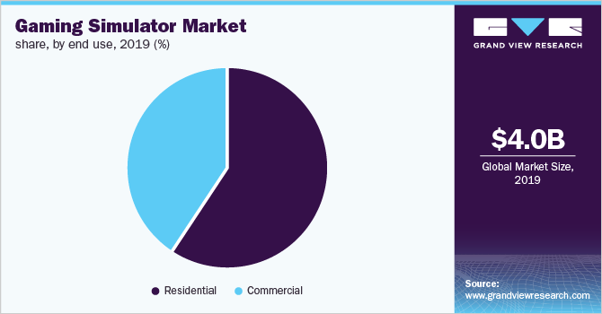

Fig4- gaming simulator market

### 5.2.3 Competitor Information

Few of the industry's largest simulator developers have dabbled in this segment of the market. But the amount of do-it-yourself and improvised solutions that veer from a standard support structure made of plastic to a hardwood basis indicates a need. They're cheap, but also immobile and quite basic.

A commercial VR simulator base finds most of its uses in arcades and racing events. Even here, the organisers craft unique bases with features like extra height for a monitor, strengthened stability, and space for marketing.

Fig5- Event platform

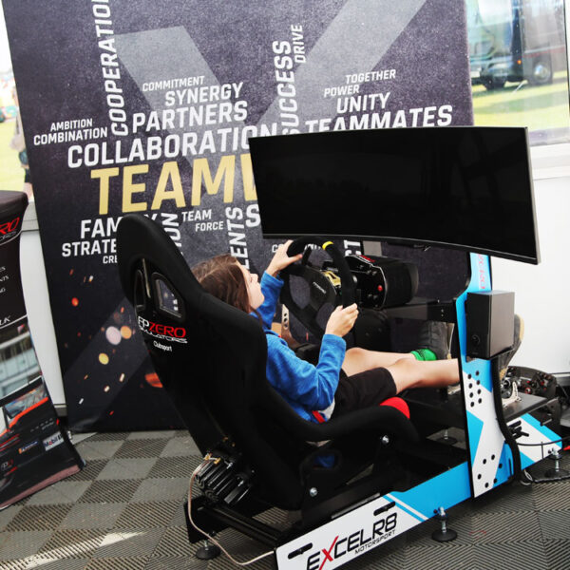

Fig6- Arcade unit

Commercial products

* Playseat floormat (£ 47)- high friction floor mat to place under the playseat.

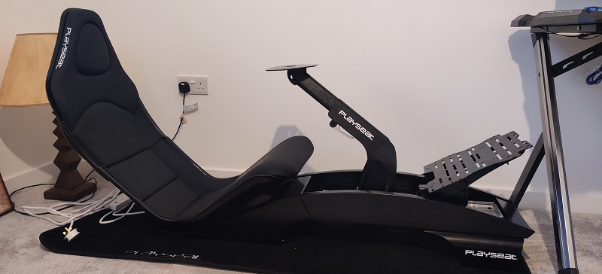

Fig7- Playset with floormat

* Playseat flight case by swan flight (£ 834) – modified flight case with wooden support structure to support the simulator with wheels .

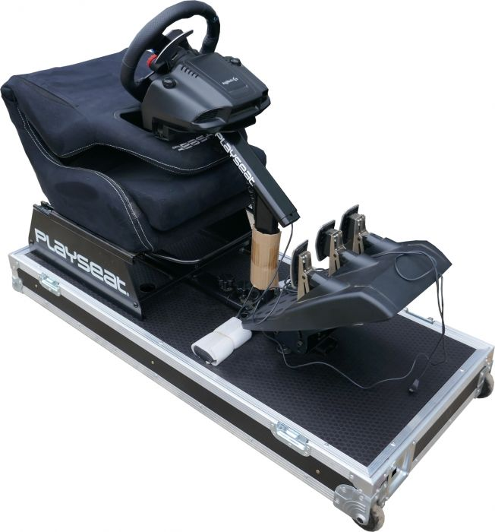

Fig8- Playseat on flight case

* Playseat flight case by playseatstore.com (£ 89) – modified flight case with wooden support structure to support the simulator.

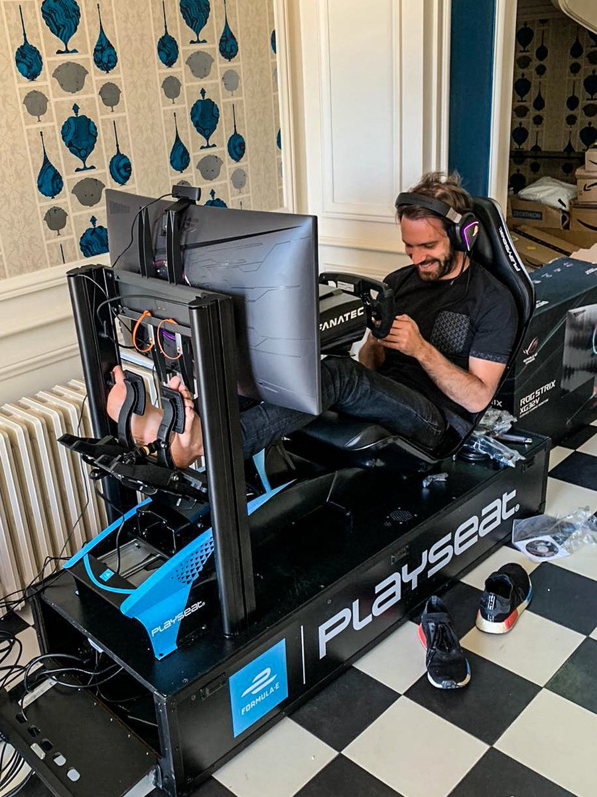

Fig9- playsetstore.com Flight case

* Dunnage Rack, 1500 lb., HDPE (£116) – HDPE table to place the playseat on.

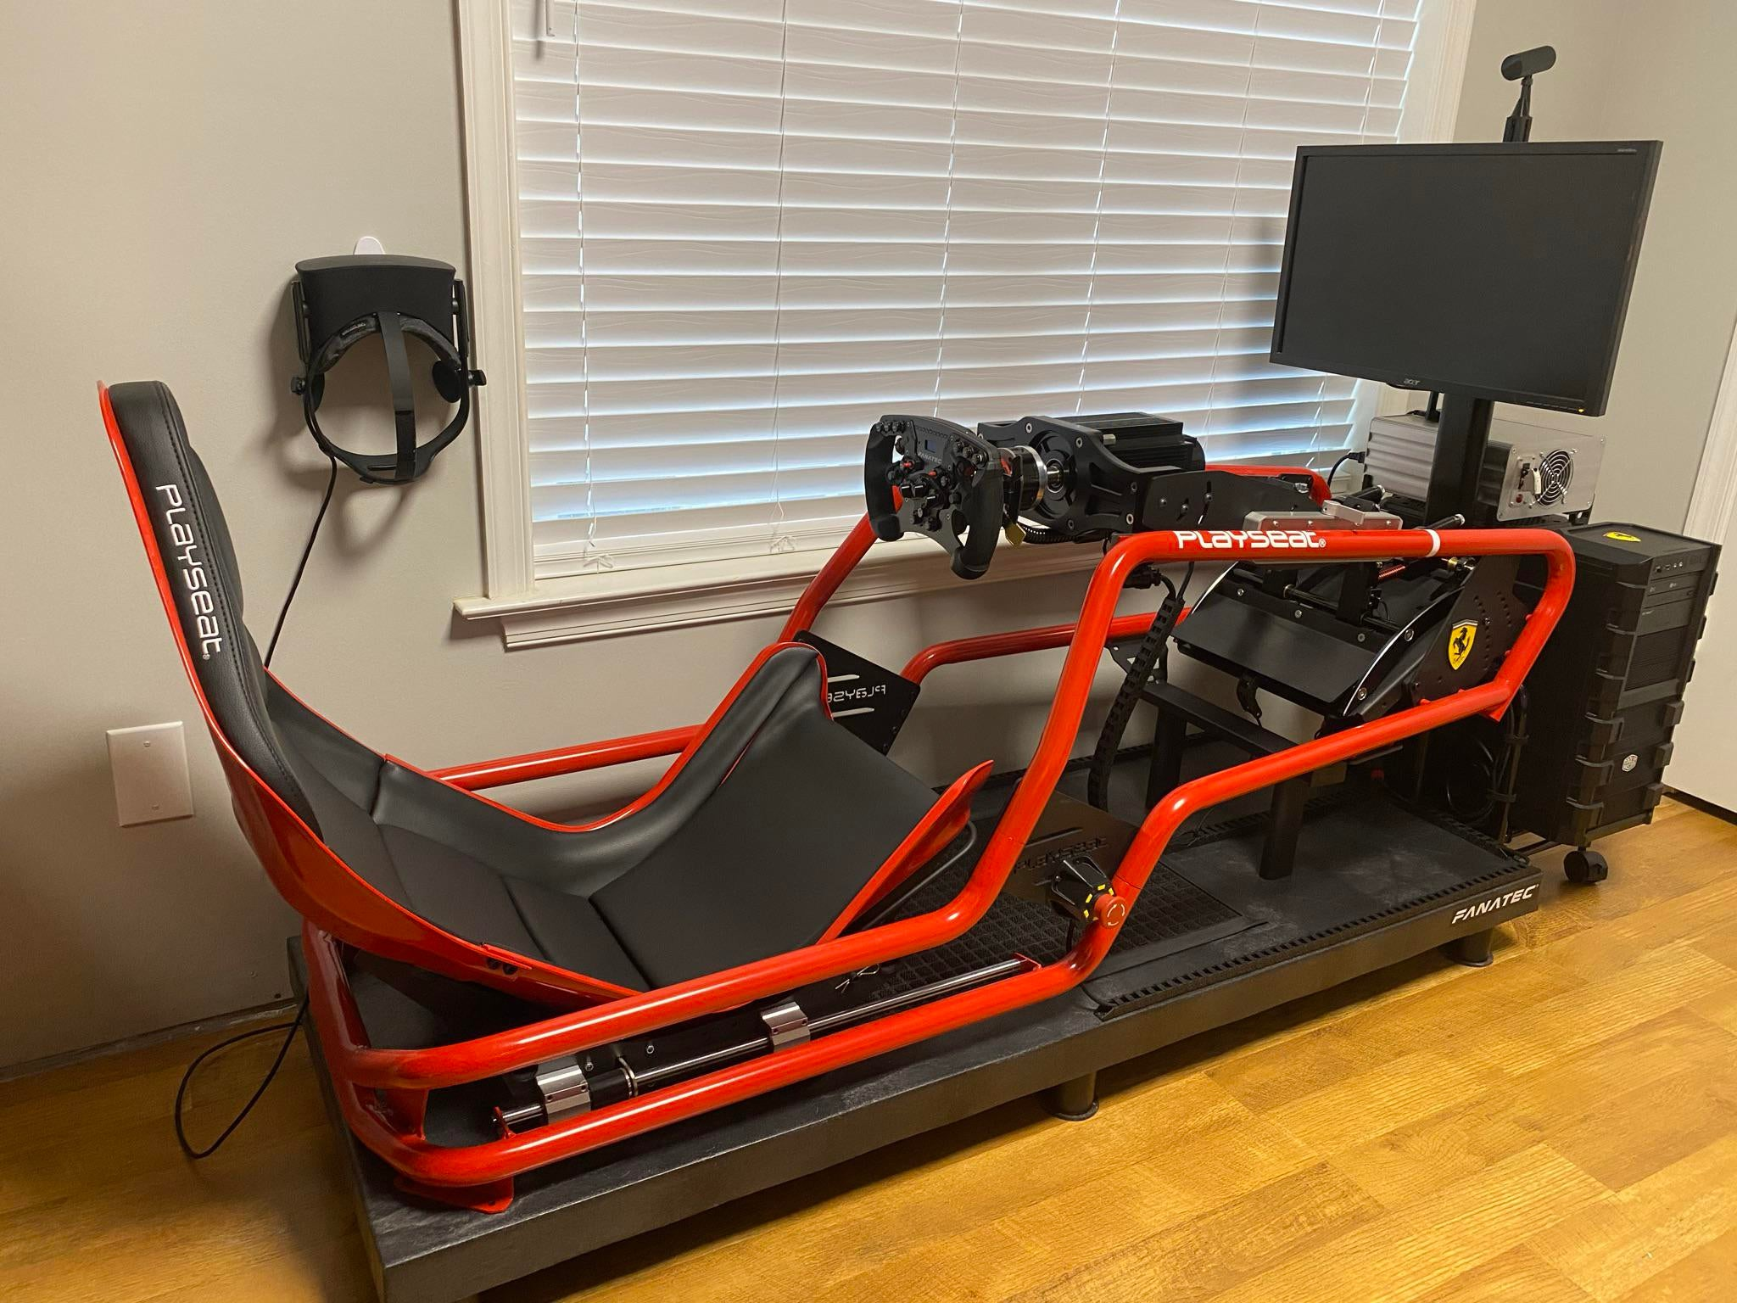

Fig10- Dunnage Rack

After through search in the market space it has been realized that there are no commercial competitor in this market space rather a trend of use if flight cases as the base or other structures made out of wood or piping’s.

Analysing the trends of currently used bases it is realised that simple boxlike design is appreciated with large logos or brandings printed on it. This found to be true for both commercial and residential users.

Fig11- Sponsored Playseat event

### 5.2.4 Estimated Market Revenue

Estimated product cost £ 100-150

Market types

* Total Addressable Market (TAM)- Sum of Basic, Advanced and Pro Rig users for the given market valuation which is $3.85 Billion.

Number of basic rig users is 53% of $3.85 billion / average basic Rig cost.

= 2091512 users

Number of advanced Rig users is 32% of $3.85 billion / average advanced rig cost.

=227020 users

Number of pro users is 15% of $3.85 billion/ average pro rig cost.

=26381 users

Total market size is 2344913 users. Although large number of users in this market don’t meet the criteria for the product to be used but this gives an idea of the potential market size. Under this market size the possible revenue can go up to £234-351 Million.

Serviceable Available Market (SAM)- Sum of Advanced and pro rig users are taken into consideration as they meet the basic criteria which is owing a VR cockpit.

Total market size is estimated to be around 253401 users. Theses are people that can be persuaded to some extent to own a mobile base. The product is not made with focus of selling to everyone in this category but can be used by everyone in this segment. The revenue in this market size is expected to be around £25-32 million.

Serviceable Obtainable Market (SOM)- It is the revenue that can be generated by selling to Pro rig users as they are the ones that are most likely to appreciate all its feature. This is the attainable market size with the current available data.

Total estimated revenue is to be considered as £2-3.9 million which can be further be concentrated using other factors for example if the product was highly marketed in on Northern America with 35% of total market, then the revenue would be around £ 0.7-1.2 million.

### 5.2.5Marketing Strategy.

* Conducting popup events with the playset to attract playseat users.
* Providing free trials to arcades and discounted price to arcades to attract residential users.
* Possibility to modify the platform to meet needs from advanced to pro players makes it attractive option for advanced players who are unsure of their use.
* Branding the product with the Simulators brand and providing colour schemes to match with the simulator makes it attractive for commercial as well as residential use.
* Digital marketing by running adds in areas with the greatest number of sales which are North America and Europe.
* Giving out free units to influencers who make content on VR simulation Racing.

### 5.2.6 Unique Selling Points

* Height adjustability
* Surface for commercial ads and logos
* Modularity to add motion simulator
* Game lightings
* Easy to assemble.
* Heigh factor of safety

Fig12- Gaming Light

Fig13- Motion simulator

## 5.3 Performance Specification

The parameters established by the Performance specification provide a basis for evaluating the developed product against predetermined standards. The proposed model will be tested with a variety of tools to gauge how well it stacks up against similar products in terms of usability, portability, and longevity in a variety of settings.

### 5.3.1 Functionality

|  |  |  |  |
| --- | --- | --- | --- |
| Performance Specification | | | |
| No. | Description | Importance (1 - 5) | Notes |
| 1. | Mass   * The overall weight needs to be low. product must be easy to carry and store when not in use | 4 | Intent- Keeping the total weight <15kg |
| 2. | Utilisation:   * Provide sturdiness to the frame * Provide mobility to the structure * Hight adjustment | 5 | The design is made with an intent to provide user with stability while using the simulator and mobility to be able to move the frame with ease. The hight adjustment is for monitor users to align the line of sight |
| 3. | Capacity-   * Taking less space * Attachable to any standard simulation unit * Handel the weight while being used | 2 | The unit has to be compact and able to support any standard frame made for racing simulation. The rigidity needs to be high to support the weight of the frame and user > 140kg |
| 4. | Lifespan:   * Since it’s a mechanical product life span depends on use * Should at least have a 2-year warranty | 3 | The base is made of mechanical parts and depends on integrity of the materials being used so should be able last a long time unless handled roughly.  The warranty of a playset is 2 years taking that as a standard for the products warranty. This would only cover any malfunction that might occur due to manufacturing defect. |
| 5. | Scope and range:   * Used as base for the simulation setup * Modular function for height extension * Modular light attachment * Height extendibility to most monitor setup * Moved over multiple surfaces * Stability on multiple surfaces * Fit wide range of simulator lengths | 5 | The product should be able to fit a wide range of simulators with various lengths and dimensions while not compromising on stability and mobility on various surface types so it could be used efficiently both indoors and outdoors.  The high extension and lighting should be a modular function as it is not needed by all users and can affect the product price. |
| 6. | Illumination:   * Lighting to fit the ambience of gaming room * Modular unit * Can be used as indicator to show simulator is being used | 2 | Modular unit that is able to synchronize with gaming to be used as indicator as well as to blend in the gaming environment |

|  |  |  |  |
| --- | --- | --- | --- |
| 7. | Effectiveness & Efficiency:   * Should be easy to set up and remove from the frame * Small no. of steps to set up and make mobile. * Easy to adjust height with indicator * Easy to setup modular units * Handel weight and movements of uses when in use | 4 | Time to setup should not be more than 30 min.  Height adjustment should have an indicator, so all side are even, and the user remembers the height.  Time to setup mod should be less than 15 min.  All joints and moving parts need to be sturdy to provide maximum stability. |
| 8. | Storage:   * Needs to be foldable or modular so it does not take much space during storage * Must be light so it is easy to store. | 2 | The product needs to within the weight rang where a single user can lift it to store when not in use. |
| 9. | Personalization:   * Available in range of colours and patterns * Surfaces to accommodate logo * Lighting mod to blend it into the environment | 3 | The product should look simply yet blend in with the gaming atmosphere because large number of users are gamers.  Various colour schemes and logos will  help it match the Frames theme and logos are good for commercial market |
| 10. | Safety guards:   * Protect the frame from collision when being moved * No sharp edges | 4 | Rugged edges to handle impact from collision from walls and doors.  No sharp edges to avoid injury during installation and general use. |
| 11. | Shape:   * Match the gaming environment and aesthetical pleasing | 2 | Should not look too much robust and be able to match the frame so it doesn’t stand out a lot. |
| 12. | Weight:   * Single users should be able carry it * Doesn’t feel heavy while moving the unit | 3 | Weight of the basic unit should be less than 5kg so its easy for single user to carry and reduce shipping charges. |

|  |  |  |  |
| --- | --- | --- | --- |
| 13. | Conductivity:   * Outer walls nonconductive to heat and electricity | 3 | Avoid conductivity in areas where user could encounter while in use to maintain neutral nature and reduce chances of hazard. |
| 14. | Interchangeable:   * Easy to mount and remove frames and other modules * Easy to repair any defective or broken components | 4 | Easy to fit and remove the frame and mods.  Easy to repair parts like wheels, lights and hight extender that are more susceptible to damage over multiple use. |
| 15. | Compatibility:   * Highly compatible with formula PLAYSEAT * Compatible with other standard frames | 3 | Standard setup method and mounting so it fits well with most units to serve a larger customer base. |
| 16. | Target Product Cost:   * Needs to be affordable * Mods should cost efficient * Cost should be able to indicate quality of the product. | 5 | Since the setup of a racing simulator is already high around 900 to 2500 the base should not take a large portion of the expenditure.  The cost should not be too low, so it is able to indicate that it is a high-quality product.  The pricing should be good enough to able to compete with DIY solution with its features. |

### 5.3.2 Materials

|  |  |  |  |
| --- | --- | --- | --- |
| Performance Specification | | | |
| No. | Description | Importance (1 - 5) | Notes |
| 1. | Appearance:   * Materials used in external parts needs to look rugged and strong. * The material finish should be suitable for the user environment | 3 | The material needs to look sturdy, so the user finds is reliable and strong.  The finishing on the outside should be not too rough or smooth so it fits in user’s environment. |
| 2. | Colour:   * Standard unit will be in black colour. * Colours on the outside should be customizable. | 3 | The standard black colour can fit in with most gaming equipment’s without standing out a lot. It also compliments lighting and logos that could be added.  Custom colours and patterns are essential for users who like to personalize their belongings. |
| 3. | Conductivity:   * Must have insulated body to not conduct heat or electricity. * Must have insulated body to protect the inner components. | 2 | It is essential that exterior is made of good, insulated casing to protect the user from any hazard that might be caused due to nearby leaking electricity or heat  Intent- Outer body to be made of insulating materials like HDPE |
| 4. | Density:   * Aesthetic plastic parts made with low density material * Structural plastic parts made with high density material * Metal parts to be made with suitable density | 3 | Weight reduction as much as possible without compromising on integrity of the product.  Intent- A right balance needs to be found between amount of different material being used to retain the overall balance in the product. |
| 5. | Elasticity:   * Elasticity in some parts that don’t directly affect the stability of the base. | 3 | Only parts like spring and shock absorbers need to be elastic and not effect the stability of the base drastically. |
| 6. | Hardness:   * Should be hard enough to withstand impacts. * All support parts need to have right amount of hardness | 2 | Material used are combination of plastics and metals so all parts need to have right balance of strength and hardness. |
| 7. | Phases:   * The product is made for operation in both indoors and outdoors so it should be able to withstand heat and doesn’t change phase. | 2 | Parts most susceptible to phase change when using in outdoors are wheels, low density parts and grip so suitable material needs to be used to withstand temp up to 60-70 C. |
| 8. | Purity:   * Can be compromised for recycled aluminium or plastic parts that meet the strength requirements | 1 | To be more eco-friendly recycled material can be used. |
| 9. | Recycling and potential:   * The materials from the product should be highly recyclable. * Easy to repair * No bonded material to be used. * Proper labelling on parts with material info and symbols | 4 | Since it is a mechanical product, all parts should be recyclable.  Easy to repair and get spare parts so they are not disposed in case of damage.  No plastic and metal binding as it makes the recycling process harder.  All parts must have labelling or symbols for easy segregation while repairing. |
| 10. | Strength:   * The body needs to have high strength * It should also be able to handle small impacts while being moved | 4 | Use of high strength material in parts that provide structural strength to increase stability.  Strength in corners to handle small impacts while being moved. |
| 11. | Texture:   * The inner body needs to be comfortable to handle and assemble * Outer surface should be slip resistant and user friendly. * Customizable finishing of outer surface. | 3 | Suitable finishing of internal components for good assembling experience.  Outer surface needs to be customizable to meet users’ needs and be printable. |
| 12. | Viscosity:   * The product should not exhibit any viscous properties since all parts are rigid or have mechanical movement. | 1 | No viscous parts present in the product except the grease in moving components like wheels. |

### 5.3.3 Dependability

|  |  |  |  |
| --- | --- | --- | --- |
| Performance specifications | | | |
| No. | Description | Importance (1 - 5) | Notes |
| 1. | Availability:   * Availability as shelf product in gaming hardware stores. * Available at most gaming online platforms. | 2 | Available for customers for both commercial and residential use. Easily available online and selective offline stores. |
| 2. | Reliability:   * Highly reliable * Warranty to match that of products in similar space | 3 | Field testing on all possible scenarios.  Warranty of around 2 Years.  Replacement parts for repair easily available. |
| 3. | Modification:   * Easy to modify to meet the user needs. * Modification available to increase the utility of the basic product. | 4 | Based on the budget and user requirements modifications can be made.  Other mods available to increase functionality of the basic product. |
| 4. | Maintainability:   * Needs periodic maintenance of moving parts like wheels and joints. * Should not be kept in continuous contact with moisture | 3 | Periodic maintenance is needed based on the amount of use. Good maintenance will increase the life of the product.  Should not be kept awaty from moisture as much as possible as it can increase the rate of corrosion of metal parts. |
| 5. | Lifecycle cost:   * Very low additional cost involved in its lifecycle | 1 | Very low cost on maintenance of the product. |
| 6. | Logistical support:   * Product will also be available on various online and offline platforms * Support to locate product during the delivery process | 2 | Delivery, Return/Replacement <1 week. |
| 7. | Disposal:   * Needs proper disposal as it contains parts that need to undergo different recycling processes * Policy for exchange for instore products * Proper guide for disposal | 2 | Can be easily disposed if gone through proper process.  Product can be retrieved or exchanged for other instore products. |
| 8. | Level of service:   * Easy to access service for maintenance or repair * Services provided for purchase and logistics. * Commercial service for custom pattern and logo printing | 4 | Company services for commercial orders like rebranding and printing patters and logos.  Online services- Delivery, return, refund, claim warranty. |
| 9. | Refurbishment:  Not enough value to refurbish | 1 | No refurbishment. |
| 10. | Redundancy:  Portability, compatibility, and easy assembly are key features | 3 | No redundancy in range of movement and compatibility. |

### 5.3.4 Environment

|  |  |  |  |
| --- | --- | --- | --- |
| Performance Specification | | | |
| No. | Description | Importance (1 - 5) | Notes |
| 1. | Access:   * All joints and parts should be relatively accessible * All fittings should be easy to access * It should be easy for an expert or trained professional to access it for maintenance or disposal purpose | 5 | Easy to assemble, modify, repair and dispose. |
| 2. | Corrosion:   * Metal supports and mechanical connector susceptible to corrosion | 5 | Necessary coatings on all metal parts to withstand some level of corrosion.  Instruction to try avoiding using in places with high moisture. |
| 3. | Erosion:   * There is little to no chance for erosion.   In case erosion occurs, product will fail. | 5 | High erosion resistance. |
| 4. | Force:   * The product should function well even after being subjected to force and impact | 3 | Should withstand impacts and movement of the user. |
| 5. | Mass:   * The mass should be minimised to make use, assembly, and storage effective | 4 | Wait of all parts when assembled should not weigh more than 5KG |
| 6. | Noise, Vibration and Shock:   * The product is shock proof * Resistance to user movements * Resistant to noise | 3 | Joints need to resist vibration.  And boy needs to absorb shock without being damaged. |
| 7. | Pollution:   * Must produce least amount of pollution as possible during its life cycle | 3 | Less pollution in packaging and transport.  Use of sustainable materials.  Product should easy be recycle. |
| 8. | Radiation:  Product is not made for use in radioactive environment | 1 | Not designed to resist radiation. |
| 9. | Relative Humidity.   * Product can withstand humid climate | 4 | Can withstand a range of 30-90% humidity.  Metal and rubber parts are most susceptible to change in humidity |
| 10. | Temperature:   * Suitable to function in outdoor and indoor temperature | 4 | Working temp without deformation of low-density plastics. 50-80 C. |

### 5.3.5Ergonomics and aesthetics

|  |  |  |  |
| --- | --- | --- | --- |
| Performance Specification | | | |
| No. | Description | Importance (1 - 5) | Notes |
| 1. | Illumination:   * Modular fitting for lighting * Able to change colours * Wire and wireless connectivity | 3 | The fitting for light needs to be modular as it significantly adds to the cost so buyer has option to opt depending on requirement.  Change light colour part of aesthetic appeal and the unit can be both wired or wireless. |
| 2. | Colour:   * Customizable to meet commercial and user needs * Using colours that are commonly found in gaming environment like black | 3 | Customization of colour and pattern on large or special orders.  Neutral dark colours on basic units. |
| 3. | Controls and display:   * The device does not contain any display parts. * Addition of mods might contain display or indicator parts | 3 | Product is completely mechanical so contains no display parts.  Mods like hight adjuster may have indication component. |
| 4. | Culture:   * Nothing culturally inappropriate in the product   No advertisement of any offensive nature | 2 | The product is simple and not offensive in any way. |
| 5. | Signs and Indicators:   * No additional sign or indicator present in device light turns on when switch is turned on | 1 | Light turns on if switch is at ON position. |
| 6. | Size and Shape:   * The size and shape vary for different concepts. But all of them are made to fit most standard Frame sizes | 3 | The shape varies depending on how movement is achieved and how the fits the frame. |
| 7. | Transportability:   * After setup easy to move and make stable. * Easy to carry when not in use. | 4 | The product needs to be smooth during mobility making it easy for the user to move the frame through complex path. |
| 8. | Visual Impact:   * Easy to understand and simple design. * Blend in the gaming atmosphere. * Looks well engineered. | 3 | Simple design and a rugged look |

### 5.3.6 Interface

|  |  |  |  |
| --- | --- | --- | --- |
| Performance Specification | | | |
| No. | Description | Importance (1 - 5) | Notes |
| 1. | Configuration:   * Easy to fit with various frames * Easy to fit mods * All functions are easy to operate and configure | 4 | All parts should be easy to assemble and understand by looking the manual.  All functions are easy to perform and have less no. of steps. |
| 2. | Compatibility:   * Compatible with most standard units * Compatible with future mods produced by the company. | 3 | Needs to support all types of standard mods.  Modular fittings produce by company in future should be compatible with the older version of the base. |
| 3. | Emissions:   * All emissions during manufacturing, packaging, delivery, and disposal should be reduced. | 2 | Eco friendly or easily recyclable materials should be selected for manufacturing and packaging.  Occupy less space so reduces emissions while being transported. |
| 4. | Heat input and output:   * Can function without problem in outdoor heat * No heat is generated | 3 | Good material selection is needed so it is highly functional in both indoors and outdoors. |
| 5. | Local utilities:   * Used with any simulator unit | 2 | Can be used as an mobile unit for moving things but main use is support simulator units and provide utility. |
| 6. | Interchangeability:   * All mods are interchangeable. * All damages moving parts are interchangeable. | 4 | It is easy to repair and modify the base unit to increase its life and functionality. |
| 7. | Use and abuse tolerance:   * Can withstand abusive use to some extent * Can withstand impacts, certain levels of heat and environmental factors like moisture | 3 | Made to endure day to day use. |

### 5.3.7 Cost and Timing

|  |  |  |  |
| --- | --- | --- | --- |
| Performance Specifications | | | |
| No. | Description | Importance (1 - 5) | Notes |
| 1. | Unit cost:   * Cost per unit online should be <£150 * Wholesale cost for order of 100 +pcs be <£100 without customization | 4 | Cost per unit is not fixed but it is dependent on the amount spent by average Racing sim owner |
| 2. | Transportation and storage:   * Transportation and storage cost can be reduced by decreasing the volume and weight of product. | 3 | Compact packing and good material selection can reduce volume and weight, hence reducing the cost. |
| 3. | Marketing and Sales factors:   * The product needs to be marked showing its unique features. * Should market it on multiple platforms. | 5 | Refer marketing section. |
| 4. | Installation and commissioning:   * Easy to use, can be self-installed. * No need additional installation service available. | 2 | No installation services or commissioning. |
| 5. | Customer support:   * Online support on delivery and refund available. * User manual and videos available to make user familiar with the product. | 3 | Delivery, return, refund, user manual and videos. |

### 5.3.8 Training and Safety

|  |  |  |  |
| --- | --- | --- | --- |
| Performance Specification | | | |
| No. | Description | Importance (1 - 5) | Notes |
| 1. | Education:   * Some knowledge of fittings and assembly is needed to use the product. * Need to keep general health and safety in mind while assembling it. | 4 | Easy to understand manual and video needs to be made to guide users in right direction.  Guidelines for safety needs to mention as well. |
| 2. | Documentation:   * Proper copy of buying receipt, H&S guidelines and user manual needed. * Proper documentation of product number and process is to be made | 3 | Proper bill, user guide, caution, and safety instructions.  Proper warranty and tracking documents are needed. |
| 3. | Language:   * Documentation supplied in few selected languages. | 1 | Following the UK market European countries shall be targeted therefore such languages as Czech, Slovakian, French, German, Lithuanian, Swedish and Norwegian must be accounted for |
| 4. | Skills and experience:   * Basic fitting and assembly skills or experience is required | 2 | Easy to use, and manual easy to follow. |
| 5. | Tools and equipment:   * Basic tools required for assembly. * Specialized tools are provided along with the product. | 2 | Basic tools are required for assembly and fitting.  Special tools related to the product need to be provided.  No additional tools to remove preassembled parts. |
| 6. | Accessibility:   * No sharp edges or corners that may be safety concern while using or assembling it | 3 | Safe to access, store and assemble. |
| 7. | Cultural:   * No offensive material used in the product. * No inappropriate branding related to the product. | 4 | No offensive use of material or branding. |

## 5.4 Regulatory Requirements

### 5.4.1 Legislation

CE Marking Requirements –

All potential dangers, such as those caused by a lack of stability, a breakage in the middle of operation, a change in surface, a shift in operating conditions, contact with moving parts, or the interaction of different machines, must be stated and safety measures must be outlined to protect against them.

Guards and other protective equipment should be specified, including the kind of guards needed, where they should be located, and how much room they have to move. Fixed guards, portable guards, and adjustable guards make up the triad of guard types.

Other dangers' risks are concerned with how far and how badly a hazard may affect a product. Electric supply, static electricity, energy other than electricity, fitting mistake, high temperature, fire, noise, vibrations, tripping, and falling are all examples of potential dangers.

Detailed instructions on how to clean and maintain the product, where to get replacement components, and what kind of tools and equipment are required should be included.

The gadget need to have the bare minimum of information and any applicable warnings. Customers should have access to all relevant safety information, including cautionary symbols, warnings about residual dangers, material marks, general principles of drafting/contents, and sales literature.

Risks posed by mechanical components, including their capabilities and potential operation environments. Wheels, mechanical strength, guide rails and rail tracks, raising and lowering weights, moving loads during handling, and controlling movement are all covered in great depth.

In addition to these rules, you need also take into account international standards like ISO's. ISO/TC 214, Elevating work platforms, is responsible for creating ISO 16368.

### 5.4.2 The following patents should not be breached-

While exploring all possible designs for mobile base it is important to know what ideas have already been explored and the concepts that cannot be used in your concept development as they may create legal issues down the product development process.

|  |  |  |  |
| --- | --- | --- | --- |
| Sno. | Patent number | Title | Autor |
| 1 | US9591919B2 | Height adjustable desk system and method | Ergotron Inc |
| 2 | US10939750B2 | Height adjustable device with concealed lift mechanism | Nicholas Robert Swartz |
| 3 | US9829151B1 | Height adjustable flat panel display mounts | Brett Stenhouse |
| 4 | US20180146775A1 | Height adjustable workstation | Xiaodong You |
| 5 | US9504316B1 | Height adjustable desktop assembly | Henry Streicher |
| 6 | US10994216B2 | Virtual reality motion simulator | David Board |
| 7 | US20120160617A1 | Baggage caster lock device | Shoji Hashimoto |
| 8 | JP3184846U | Caster lock device for bags | T&S CORPORATION |
| 9 | US7225903B2 | Shopping cart tilt and tip prevention device | Jay S. Means |
| 10 | US20180319214A1 | Braking and locking system for caster wheels | Shadi RENNO |
| 11 | US6163924A | Swivel caster assembly with releasable lock mechanism | Scott Corley |
| 12 | JP4908825B2 | Caster locking device | Okamura Corp |
| 13 | JP2010201972A | Double-wheel caster | Masuo Katada |
| 14 | US20190039637A1 | Housekeeping cart with wall protectors | Michael Thuma |
| 15 | US9993378B2 | Method and apparatus for a locking caster | Michael Turturro |
| 16 | US8967636B2 | Hubless wheel and related stroller | Andrew J. Horst |
| 17 | US5419619A | Hubless wheel | Paul E. Lew |
| 18 | DE102014220988A1 | Steerable wheel suspension for a hubless wheel | Daniel Wolf |
| 19 | US9573417B2 | Hubless wheel | Lei Feng |
| 20 | US3680495A | Pallet structure | Daniel W Pike |
| 21 | US10699591B2 | Motion simulator | Jean Paul Warmerdam |
| 22 | KR101250429B1 | Motion simulator | 전상곤 |
| 23 | US9520018B2 | Controlling priority of wagering game lighting content | Edward G. Brunell |
| 24 | JP6474780B2 | Apparatus, method and system for mounting an object on a mounting surface | Lee Christopher Franklin |

# 6. References

* <https://www.cognitivemarketresearch.com/sim-wheel-stand-market-report>
* <https://www.grandviewresearch.com/industry-analysis/gaming-simulator-market>
* <https://www.marketresearchfuture.com/sample_request/9560?utm_source=RD_infograph>
* <https://www.businesswire.com/news/home/20170104006089/en/Technavio-Says-the-Global-Gaming-Simulator-Market-is-One-of-the-Fastest-growing-Gaming-specific-Hardware-Markets>
* <https://simracewebshop.com/product/formula-intelligence-mercedes-amg-f1/>
* <https://op.europa.eu/en/publication-detail/-/publication/9cc06d44-9c8d-4b04-9d3a-b9f3d300cdd5>
* <https://www.iso.org/obp/ui/#iso:std:iso:16368:ed-2:v1:en>
* <https://www.hse.gov.uk/pubns/indg478.pdf>
* <http://playracecraft.com/racecraft-racing-seat/>

# 7. Appendix

Grading system for moving platforms with load.

Types of VR simulator

Playseat-

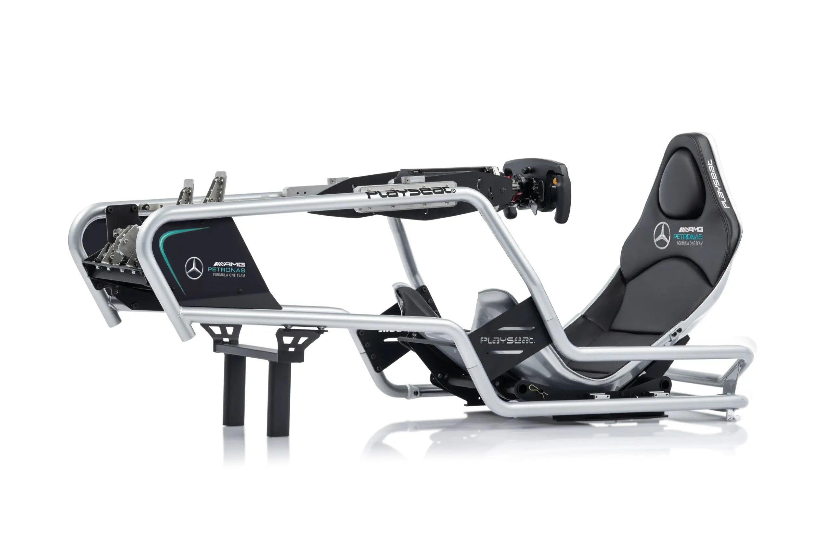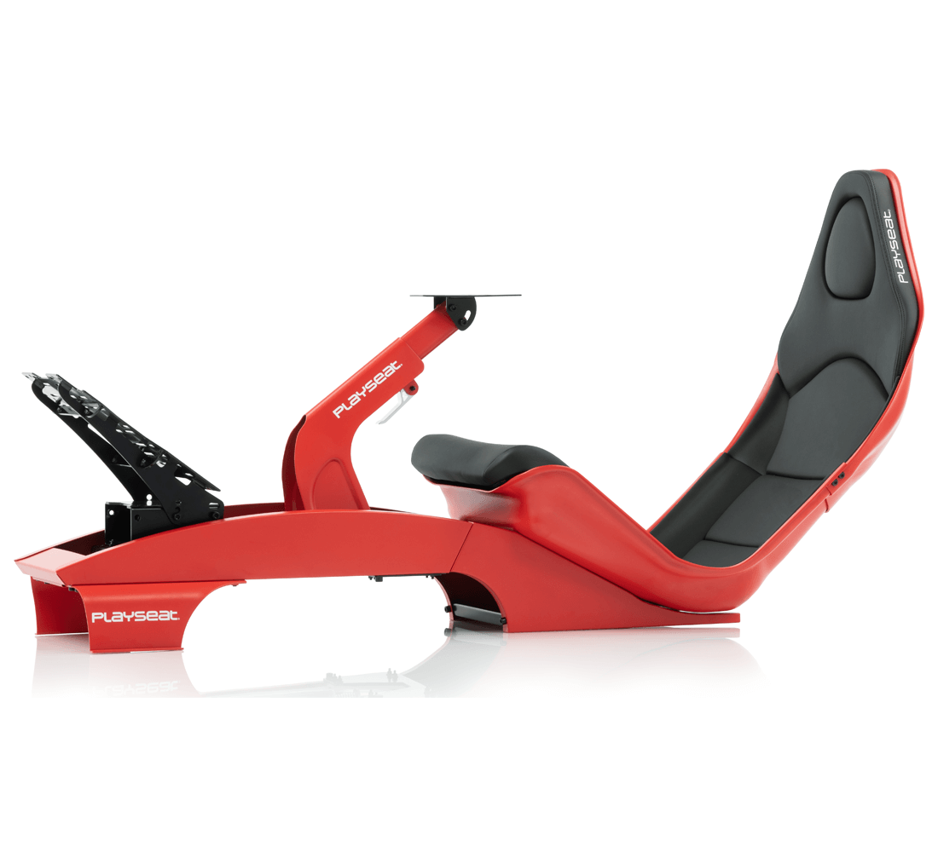

### 10.3 Manufacturing Data:

10.3.1 Bill of Materials (BOM)

The bill of materials (BOM) that can be seen below lists all of the product's components. The following table also includes a breakdown of the amount and components that went into the production of each individual element.

|  |  |  |  |  |
| --- | --- | --- | --- | --- |
| S.no. | Part Name | Material | Quantity | Manufacturing process |
| 1. | Base Frame | S420 | 1 | Welding |
| 2. | Main frame cover | Recycled HDPE | 1 | Injection moulding and machining |
| 3. | Support Structure1 | ABS+30% glass fibre | 6 | Injection moulding and machining |
| 4. | Support Structure2 | ABS+30% glass fibre | 6 | Injection moulding and machining |
| 5. | Support connectors 1 | SS316 | 6 | Outsourced- McMaster-Carr |
| 6. | Support connectors 2 | SS316 | 6 | Outsourced- McMaster-Carr |
| 7. | Top cover | Recycled HDPE | 1 | Injection moulding |
| 8. | Metal mounting board | SS316 | 1 | Laser/ water Jet cutting |
| 9. | Under mount board | Acetal Copolymer + 30% Glass Fiber | 1 | Injection moulding and machining |
| 10. | Top connecting Bolt | SS316 | 2 | Outsourced- McMaster-Carr |
| 11. | Light diffuser casing | Transparent PP | 4 | Injection Moulding |
| 12. | LED housing | Polypropylene | 4 | Injection Moulding |
| 13. | Tension panel1 | Polypropylene | 2 | Injection Moulding |
| 14. | Tension panel2 | Polypropylene | 2 | Injection Moulding |
| 15. | Control Panel | HDPE& PCB boards | 1 | Outsourced |
| 16. | Wheel Outer case | Polyurethane | 4 | Injection Moulding |
| 17. | Wheel inner core | polypropylene | 4 | Injection Moulding |
| 18. | Breaking gear | polypropylene | 8 | Injection moulding and machining |
| 19. | Base Cover | Recycled HDPE | 1 | Injection moulding and machining |
| 20. | Breaking pad support | SS316 | 8 | Waterjet/ laser cutting and then bending |
| 21. | Brake pads | Rubber | 8 | Moulding |
| 22. | Foot lever | HDPE | 1 | Injection moulding and drilling. |
| 23. | Cam lever | A356 | 4 | Milling and drilling |
| 24. | Cam Bearing | Acetal | 4 | Injection moulding |
| 25. | Cam slider | HDPE | 1 | Injection moulding and drilling |
| 26. | Cam Handel | ABS | 1 | Injection moulding |
| 27. | Hinge joint 1 | ABS+30% glass fibre | 2 | Injection moulding and drilling |
| 28. | Hinge joint 2 | ABS+30% glass fibre | 2 | Injection moulding and drilling. |
| 29. | Hinge joint plastic bearing | Acetal | 2 | Injection moulding |
| 30. | Hinge joint plastic bearing | Acetal | 4 | Injection moulding |
| 31. | Base Gripper | Rubber | 1 | Moulding |
| 32. | Allen key Bolt- M10*55mm | SS316 | 2 | Outsourced- McMaster-Carr |
| 33. | Allen key Bolt- M10*45mm | SS316 | 2 | Outsourced- McMaster-Carr |
| 34. | Allen key Bolt- M8*65mm | SS316 | 2 | Outsourced- McMaster-Carr |
| 35. | Allen key Bolt- M8*12mm | SS316 | 6 | Outsourced- McMaster-Carr |
| 36. | Allen key Bolt-M6*8mm | SS316 | 24 | Outsourced- McMaster-Carr |
| 37. | Allen key Bolt- M8*35mm | SS316 | 2 | Outsourced- McMaster-Carr |
| 39. | Hex Nut M10*5 mm | SS316 | 4 | Outsourced- McMaster-Carr |
| 40. | Hex Nut M8*5 mm | SS316 | 4 | Outsourced- McMaster-Carr |
| 41. | Hex Nut- M6*4mm | SS316 | 24 | Outsourced- McMaster-Carr |

10.3.2 2D Technical Drawings:

### 10.4 Analysis-

Design elastic bending moment resistance of SHS 50/3 Mel,Rd [kNm] = 3.27 KNm

HDPE parts –

Moulding conditions

.

Recycled HDPE loss in 8% of original strength while 3% increase in hardness

ABS

Moulding conditions

Mould analysis-

### 10.5 Miscellaneous:

10.5.1 Mind Map:

10.5.2 Gantt Chart

